Lok Sabha Analysis 2019

1. INTRODUCTION :

* The Lok Sabha is composed of representatives of people chosen by direct election on the basis of Universal Adult Suffrage. The Constitution of India allows for a maximum of 550 members in the House, with 530 members representing the States and 20 representing the Union Territories. The 17th Lok Sabha was formed by the members elected in the 2019 Indian general election. Elections, all across India, were conducted in seven phases from 11 April 2019 to 19 May 2019 by the Election Commission of India.

*The Bharatiya Janata Party received 37.36% of the vote, the highest vote share by a political party since the 1989 general election, and won 303 seats, further increasing its substantial majority. In addition, the BJP-led National Democratic Alliance (NDA) won 353 seats

2) PROBLEM DEFINITION & DESIGN THINKING :

Problem Understanding, also known as Problem Definition or Problem Identification, is the initial and critical phase of any data analysis or problem-solving process. It involves gaining a clear and comprehensive understanding of the problem at hand, its context, scope, and objective

2.1) Emphathy Map

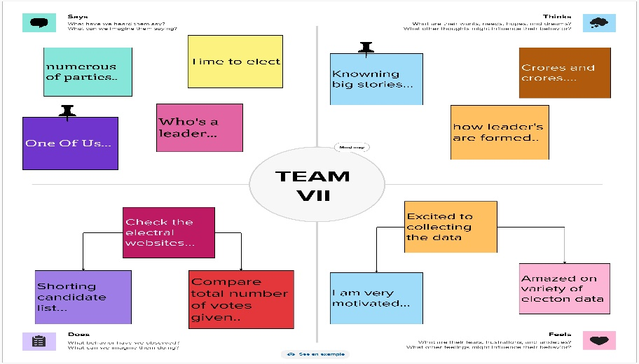

2.2) IDEATION & BRAIN STORMING MAP

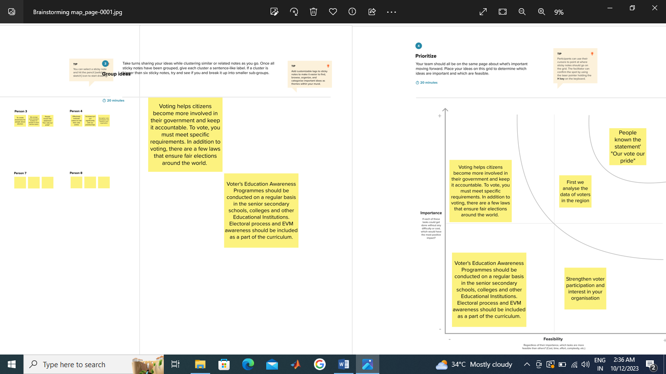

3) RESULT :

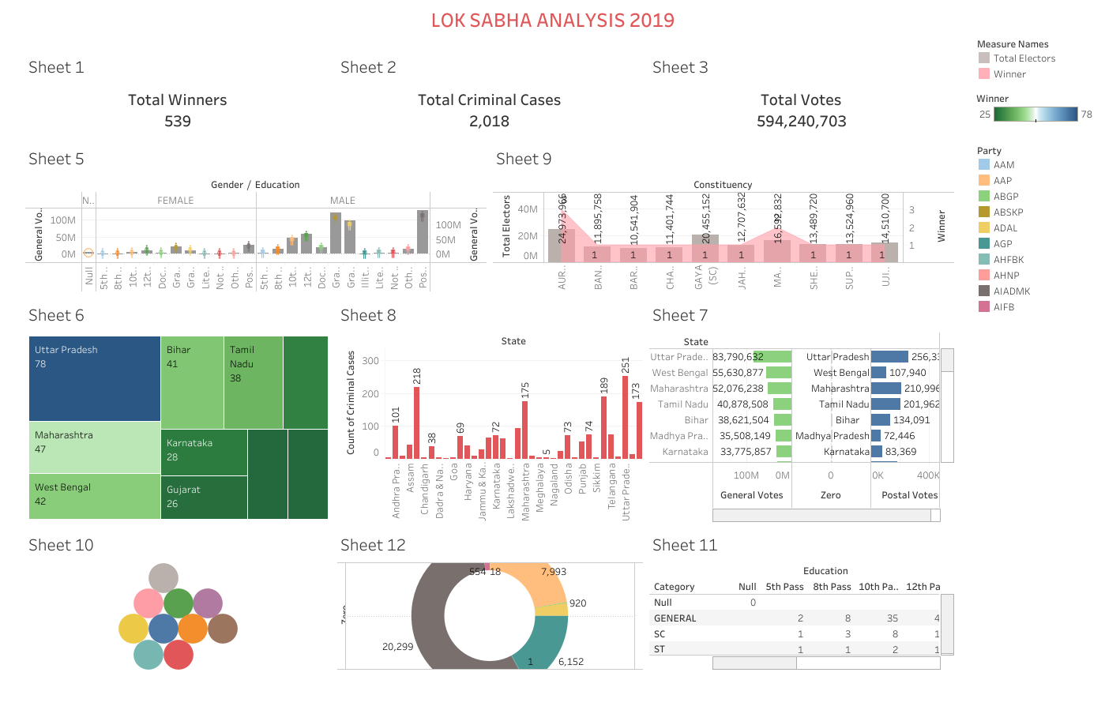

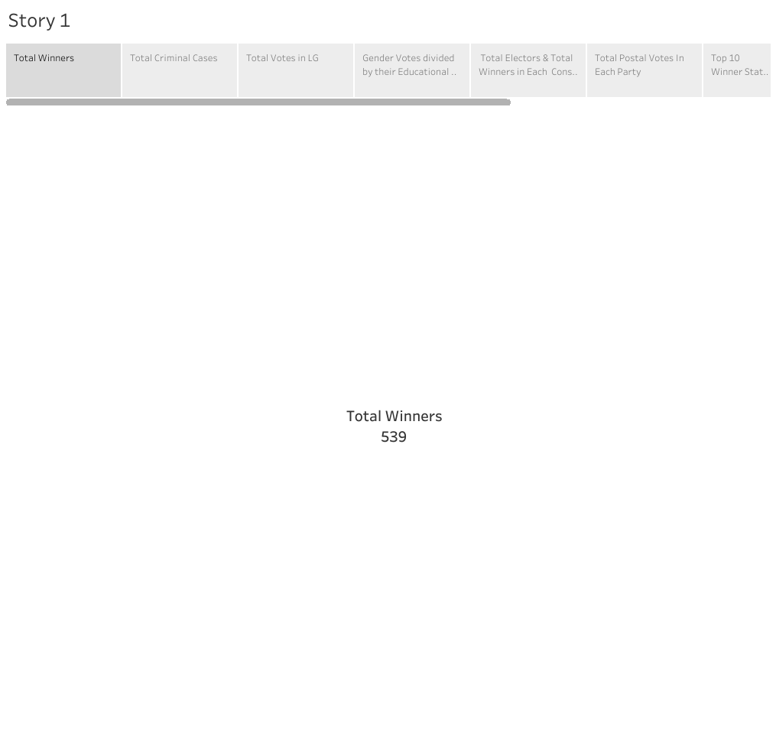

5) ADVANTAGES & DISADVANTAGES :

1. id Identifying Trends: By analyzing historical data and election results, quantitative analysis can entify long-term electoral trends, such as the performance of certain parties or candidates in specific regions, which can inform campaign strategies.
2. Demographic Analysis: Quantitative analysis allows for the examination of voter demographics, which can help in targeting specific groups and crafting messages that resonate with different segments of the population.
3. Comparative Studies: Researchers can use quantitative analysis to compare different constituencies, states, or regions, identifying variations in candidate performance, voter turnout, and other factors. This information can be valuable for understanding regional variations and addressing specific issues.

1) Simplification of Complex Issues: Quantitative analysis often reduces the complex backgrounds, issues, and qualifications of candidates to numerical values. This can oversimplify the factors that influence voter decisions and may not capture the full context of an election.

Lack of Context: Quantitative analysis may not account for the local context and dynamics that are critical in Indian elections. Factors like caste, religion, and regional sentiment often play a significant role, but they can be challenging to quantify accurately.

Data Quality: The quality of data used in quantitative analysis can be a limitation. Inaccurate or incomplete data on candidates, their financial declarations, and their backgrounds can lead to misleading conclusions.

5) APPLICATIONS :

1. **Prediction and Forecasting**: Quantitative analysis, including opinion polls and exit polls, was used to predict the likely outcomes of the elections. These predictions provided valuable insights into the potential winners in various constituencies and at the national level.
2. **Voter Behavior Analysis**: Researchers and political analysts used quantitative analysis to understand voter behavior. This involved studying demographic factors, historical voting patterns, and socioeconomic indicators to predict how different segments of the population were likely to vote.

Constituency Profiling: Quantitative analysis allowed for the profiling of individual constituencies. This involved assessing the local issues, caste dynamics, and candidate performance in past elections to predict outcomes and strategize campaigns.

Candidate Evaluation: Political parties used quantitative analysis to evaluate their candidates' strengths and weaknesses. This included assessing a candidate's popularity, public perception, and electability based on various data sources.

**Post-Election Analysis**: After the election, quantitative analysis was used to analyze the results and assess what worked and what didn't for various parties. This helped in post-election introspection and strategy planning for future elections.

6) CONCLUSION :-

* Various organizations, including political parties, media houses, and independent analysts, conducted quantitative analyses of the election results. This involved gathering and analyzing data from different constituencies to draw conclusions about the election outcome.
* Key quantitative metrics analyzed include the number of seats won by each political party, vote share, margin of victory, and performance in various regions.

7) FUTURE SCOPE :

1. **Predictive Modeling**: Utilizing data from the 2019 Lok Sabha elections, predictive modeling techniques can be developed to forecast election outcomes in subsequent elections. These models can incorporate candidate-specific data, including their qualifications, criminal records, and campaign expenditures, to make more accurate predictions.
2. **Impact of Candidate Background**: Analyzing the influence of candidates' backgrounds on their electoral success can be an essential area of study. Researchers can investigate how factors like education, caste, and gender influence voter preferences and electoral outcomes.
3. **Social Media Analysis**: The role of social media in election campaigns has been growing significantly. Future analyses can focus on how candidates' social media activities impact their electoral performance and the degree to which it influences public opinion.

Policy Impact Analysis: Quantitative analysis can assess how elected candidates have influenced policy decisions and governance at the national level. This can help in evaluating the effectiveness of specific candidates in delivering on their promises and representing their constituents. The scope of quantitative analysis in understanding electoral dynamics is vast and can evolve with advancements in data collection, analytics techniques, and emerging trends in politics. Researchers and political analysts are likely to continue exploring these areas to gain a deeper understanding of how candidates impact elections and governance in India.